|  |  |
| --- | --- |
| **name** | **Roll number** |
| Sayan Dasgupta | 15 |
| Soumodeep Ghosh | 22 |
| Ranadip Majumder | 33 |
| Swarttik Singha Roy | 51 |



**Under the supervision of**

|  |  |  |
| --- | --- | --- |
|  | | |
| Voice of Energy Meter | | |
|  | | |
| **Team Members :** | | |
|  | |  |
|  | |  |
|  | |  |
|  | |  |
|  | |  |

**Poulami Ghosh**

2022

*Final Year Project Report*

Department of Electrical Engineering, STCET

Contents

Vision of the Institute: 2

Mission of the Institute: 2

Vision of the department 2

Mission of the department 2

Program Educational Objectives (PEO) 2

Program Specific Outcome (PSO) 2

Project Outcome 2

Project Outcome versus Program outcome (PO) Matrix: 2

Project Planning & Finance 2

PROJECT PLAN 2

PROJECT COST 2

ACKNOWLEDGEMENT 2

INTRODUCTION 2

OBJECTIVE 2

LITERAURE REVIEW 2

METHODOLOGY 2

Block Diagram / Circuit Diagram / Flowchart 2

DETAILS OF COMPONENTS REQUIRED 2

RESULTS and OUTPUT 2

PHOTOGRAPH / SCREENSHOT OF ACTUAL MODEL/PRODUCT 2

APPLICATIONS 2

CONCLUSIONS AND FUTURE SCOPE 2

LIST OF REFERENCES 2

# Vision of the Institute:

To evolve as an industry oriented, research-based Institution for creative solutions in various engineering domains, with an ultimate objective of meeting technological challenges faced by the Nation and the Society.

# Mission of the Institute:

* To enhance the quality of engineering education and delivery through accessible, comprehensive and research-oriented teaching-learning-assessment processes in the state-of-art environment.
* To create opportunities for students and faculty members to acquire professional knowledge and develop managerial, entrepreneurial and social attitudes with highly ethical and moral values.
* To satisfy the ever-changing needs of the nation with respect to evolution and absorption of sustainable and environment friendly technologies for effective creation of knowledge-based society in the global era.

**Department of Electrical Engineering**

# Vision of the department

To create a strong research-based teaching and learning environment that will cater to the needs of modern Electrical Engineering.

# Mission of the department

* To produce recognized industry-ready professionals in Electrical Engineering, through educational program incorporating practice and project based teaching-learning processes.
* To enhance knowledge in Electrical Engineering, through research for sustainable development of the society and the nation as a whole.
* To promote social, environmental and technological responsiveness related to electric power through dissemination of knowledge.

# Program Educational Objectives (PEO)

Graduates of Electrical Engineering Program shall

* **PEO1:** Have Skills, in-depth knowledge and proficiency in the core areas of Electrical and other related interdisciplinary engineering domains.

**PEO2:**  Become successful practitioners in Electrical industries and/or to be ready for entrepreneurship keeping in view of the global and national requirements.

**PEO3:** Have leadership qualities, ethical values and social commitment towards environment aligned utilization of electrical energy.

# Program Specific Outcome (PSO)

**PSO1: Professional skills:** Students shall have abilities to take challenges associated with electrical power and renewable energy generation, transmission, distribution and utilization.

**PSO2: Competency:** Students shall qualify at the State, National and International level competitive examination for employment, higher studies and research.

Voice of Energy Meter

Team Members :

1. Design an economic, user-friendly, Smart Energy Meter for welfare and benefit of the society.
2. Apply the theoretical knowledge of various subjects like Electrical measurements, Power system, Circuit Theory, Software engineering, Signal system for designing of the product.
3. Apply modern tools and websites like Arduino, ESP 266MODULE, other recent trending tools and thingspeak.com for implementing the project.
4. Coordinate among the team members, put together the individual efforts, interacting among team members and working as a unit for solving engineering problems.
5. Understand the different environmental problems and apply ethical principles and commit to professional ethics and norms of engineering practices.
6. Recognizing the need for, and have the preparation and ability to engage independent and life-long learning in the broadest content of technological change.
7. Plan the project for individual activities and combined activity of team as well as plan the cost to make it a less expensive product.

# Project Outcome versus Program outcome (PO) Matrix:

|  |  |  |  |  |  |  |  |  |  |  |  |  |
| --- | --- | --- | --- | --- | --- | --- | --- | --- | --- | --- | --- | --- |
| Project Outcome No./POs | PO1 | PO2 | PO3 | PO4 | PO5 | PO6 | PO7 | PO8 | PO9 | PO10 | PO11 | PO12 |
| 1 |  |  | 3 |  |  | 3 |  |  | 2 |  | 2 |  |
| 2 | 3 | 2 | 2 | 2 |  |  |  |  | 2 |  | 3 |  |
| 3 |  |  |  | 2 | 3 |  |  |  | 2 |  | 3 |  |
| 4 |  |  |  |  |  |  |  |  | 3 | 2 | 2 |  |
| 5 |  |  |  |  |  |  |  |  | 2 |  | 2 |  |
| 6 |  |  |  |  |  |  | 2 | 3 | 2 |  | 2 | 3 |
| 7 |  |  |  |  |  |  |  |  | 2 |  | 2 |  |

# Project Planning & Finance

## PROJECT PLAN

|  |  |  |  |
| --- | --- | --- | --- |
| **ACTIVITY** | **ALLOCATED TO** | **RESOURCE REQD.** | **TIME TO COMPLETE** |
| Literature Survey | Sattwick Singha Roy | Study from past research papers and internet | 09.10.21 - 23.10.21 |
| Selecting the most feasible and economic method of implementation | All Group Members | Study from internet | 24.10.21 - 31.10.21 |
| Drawing the Block Diagram of the project and flow chart of the program | Sayan Dasgupta | Study from internet | 01.11.21 - 09.11.21 |
| Making the Simulation in Proteus | Sayan Dasgupta | Computer | 10.11.21 - 20.11.21 |
| Writing the project report | Sayan Dasgupta | Computer | 21.11.21 - 03.01.22 |
| Making the Presentation on the Topic | Soumyadeep Ghosh | Computer | 04.01.22 - 06.01.22 |

CERTIFICATE OF APPROVAL

This is to certify that the project entitled “Voice of Energy Meter” in partial fulfilment of requirements for the award of B.Tech degree in Electrical Engineering, submitted in the Department of Electrical Engineering at St. Thomas’ College of Engineering & Technology, Kolkata under Maulana Abul Kalam Azad University of Technology, West Bengal is an authentic record of our own work carried out under the supervision of **Poulami Ghosh**, Department of Electrical Engineering.

The matter presented has not been submitted by me/us in any other University / Institute for the award of B.Tech. Degree.

The names of the students are as follows: -

1. Name with University roll number ______________

2. Name with University roll number ______________

3. Name with University roll number ______________

4. Name with University roll number ______________

This is to certify that the above statement made by the candidates is correct to the best of my knowledge.

__________________ _________________

**Poulami Ghosh** Prof. S.K Biswas

Project Mentor Head of the Department

Dept. of Electrical Engineering Dept. of Electrical Engineering

_____________________

External ExaminerACKNOWLEDGEMENT

# Working on Such a project has led me and my other teammates to know many thing on modeling, creating simulations, and many more.

# I would like to thank my mentor and teacher Poulami Ghosh to guide us on our learning journey during the project implementation.

# I would also like to thank my institute for allowing us to work on such an incredible project.

# INTRODUCTION

Now a days everything is getting a makeover by getting smart be it people or electronics. Our Project is now trying to make the energy meter smart.

Our objective is to make a smart energy meter which informs the consumer on how much of energy is consumed by the consumer via SMS.

# OBJECTIVE

The objective of our Project is to keep the Consumer updated on amount to energy consumed by a System in which the consumer wants to monitor.

We wish to attend this feat by keeping the Consumer informed on the amounts of Watts Consumed by the monitored system and sending the information to the Consumer over Short Messaging Service, that is SMS in short.

# LITERATURE REVIEW

Before starting to work on this project we had to go through some of the documentations and reports of many authors in this field.

Like:

[1] General Application Research on GSM Module

[2] Programmable Energy Meter with Bill Estimation for Reducing Power Bill

# METHODOLOGY / DESCRIPTION OF THE PROJECT

The device works in a simple manner. The microcontroller gets information on the amount of power consumed by the circuit, which displays the value in the LCD Display and send that information to the Consumer via SMS service by the GMS module.

# BLOCK DIAGRAM / CIRCUIT DIAGRAM / FLOWCHART

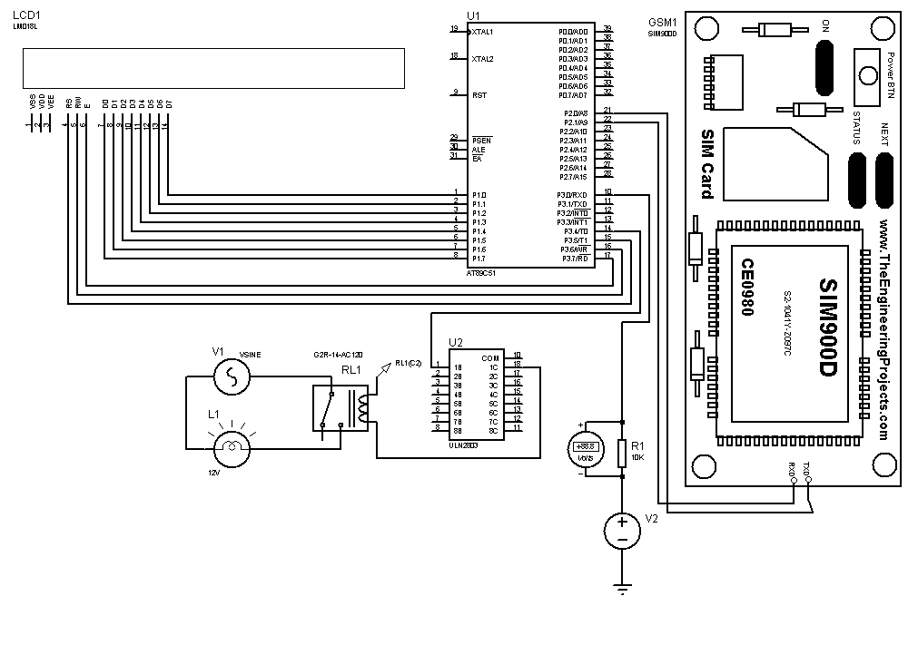

# DETAILS OF COMPONENTS REQUIRED

The Details of the Required Components are:

1. GSM Module
2. Microcontroller
3. Power Supply
4. ULN2003A (RELAY DRIVER)
5. Relay
6. Lamp (as load)

# RESULTS and OUTPUT

Right Now, Only the Voltage is being displayed and we are working on the Current Portion.

# APPLICATIONS

The applications of this project are very wide.

It will enable a customer to get the details of the amount of electrical energy consumed by the monitored network, where ever he/she is, via SMS service.

It will be also helpful for people who cannot read an electrical energy meter and reduce wastage of electrical energy.

# CONCLUSIONS AND FUTURE SCOPE

Right now, the device only informs the Consumer about the amount of electrical energy consumed in the monitored circuit via SMS service. But in future we are also thinking of notifying the user over email, and also via sound.

In future this device can also pair with a smart home assistant like Siri of Apple, Alexa of Amazon and notify them over via their services.

# LIST OF REFERENCES

|  |  |  |  |
| --- | --- | --- | --- |
|  | Citation | Authors’ Name | Year |
| [1] | M. Yuchun, H. Yinghong, Z. Kun and L. Zhuang, "General Application Research on GSM Module," 2011 International Conference on Internet Computing and Information Services, 2011, pp. 525-528, doi: 10.1109/ICICIS.2011.137. | M. Yuchun, H. Yinghong, Z. Kun and L. Zhuang | 2011 |
| [2] | Programmable Energy Meter with Bill Estimation for Reducing Power Bill Gurram Dheeraj Reddy #1 , Gaggalapally Kalyani #2 ,Gande Sai Ganesh#3 , G. Anitha Chowdary#4 #1,2,3 Under Graduate Students, ECE Department, #4 Associate Professor , ECE Department | Gurram Dheeraj Reddy,  Gaggalapally Kalyani ,Gande Sai Ganesh , G. Anitha Chowdary | 2019 |